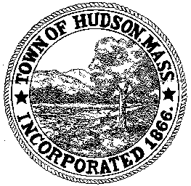

CONSERVATION COMMISSION
78 Main Street, Hudson, MA 01749
(978) 562-2020

Leif Longtine, Chairman David Esteves, Vice Chairman Paul Byrne, Member

Terrence Joyce, Member Joseph Rodrigues, Member W. Minot Wood, Member

Meeting Agenda
May 30, 2013
7:00 P.M.

- Preliminaries
  - Open Meeting
  - Roll Call

2.0 New Business
2.1 DEP 190-0562 Amendment to the Order of Conditions
Applicant: Calebe DeCastro
Location: 80 River Street
Project: install a 6’ chain link fence on property between 78 and 80 River Street and along the back of the property.

2.2 RDA 445
Applicant: Stella Realty Partners Hudson, LLC
Location: 34 Tower Street
Project Description: Resurface the existing paved parking lot, remove vegetation within the 100’ buffer zone.

2.3 RDA 446
` Applicant: Andrew and Lynn Pollock
Location: 16 Lyman Avenue
Project Description: Removal of several trees which are close to the house and utility wires and are creating a safety concern.

2.4 RDA 447
Applicant: Douglas Hodge
Location: 18 Lakeside Avenue
Project Description: the installation of drainage and catch basin, knee wall, walkway, sod, plantings and driveway paving.

2.5 Wal-Mart

2.6 DPW Water Main issue at Water Treatment

2.7 David Mercer – Commission Interest

2.8 Minutes – May 2, 2013

2.9 Central Mosquito Control Projects

3.0 Old Business
Correspondence from Town Counsel

4.0 Adjournment

